起點  領10000元 | Giannis  Antetokounmpo  22500 | Kevin  Durant  23500 | Anthony  Edward  22000 | 私闖球員民宅  -22000
LeBron Raymone James  27500 | 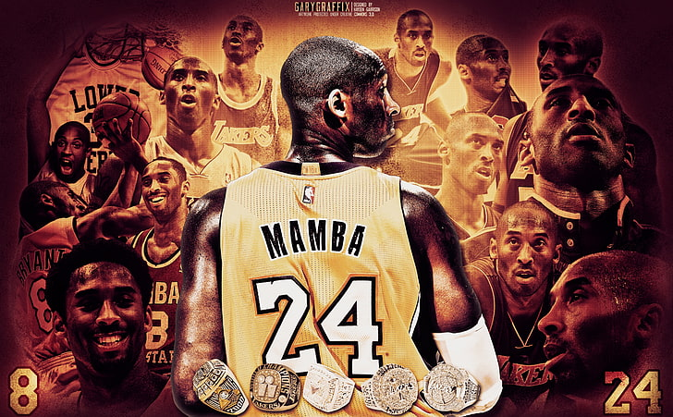  NBA球員大富翁 |  |  | Stephen  Curry  23000
Kobe Bean Bryant  29000 |  |  |  | Jayson  Tatum  20000
Michael Jordan  30000 |  |  |  | Cade  Cunningham  19000
Victor Wembanyama  20500 |  |  |  | Luka  Dončić  21500
Nikola  Jokic  24999 |  |  |  | Donovan Mitchell  20000
遇到阿基里斯 腱斷裂  -50000 | Anthony  Davis  21000 | ShaiGilgeous-Alexander  25000 | Lebron James  21000 | Jaylen brown  21000

