STAR T  +2100 | 542+583+975=  =  +5489  -5483 | 75-213=  -52538  +2552 | 858+584=  -5546  +4512 | 8555-5653=  +2556  -1555
2564+4265  =  +5565  -5455 |   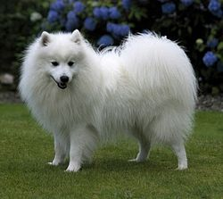  數習 |  |  | 5898-849=  +1565  -4659
5955+1865=  +4855  -6626 |  |  |  | 4555+6596=  +2551  -5246
1554+2562=  +1515  -5615 |  |  |  | 2845+6162=  +1531  -2555
5485+5565=  -5659  +1625 |  |  |  | 2546+1565=  +5586  -2564
5562+585=  +4445  -954 |  |  |  | 5655-2462=  +5355  -1965
5555+5851=  +1656  -5554 |  |  |  | 9493+5348=  +2564  -1624
5454+8552=  +8555  -5162 | 2626+2512  +1825  -1854 | 5565+5625  +4522  -1564 | 2562-1522=  +2546  -1548 | 5663+3592=  +1552  -1626

