起點  +20689 | 遇到悲鳴嶼行冥+564454545  26565454544  454545444 | 遇到蛇柱依黑小笆內 | 遇到蟲柱胡  蝶忍
斬殺異能鬼  +3058441451521  54545454541548 |   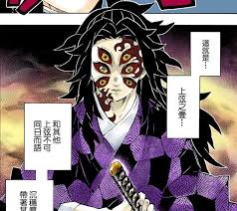              .
遇到鬼舞时無慘
-538946951555
96555565355644
21515151544544
從選拔中活下來
+3968775455451
55444444564545
44454545
獲得日輪刀
+398675565363
遇到緣一保護
-968676398725
69542857555558
241124545451
斬殺累+963852748582
56458485282855
斬殺黑死牟  +4545465956566  25454153154254  45454541545455 | 主公自殺+454  48454545454  45656154545 | 跟封柱不死川實彌執行任務+4545454545  4214565526

