40609
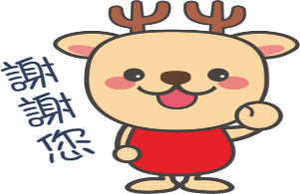
母湯節快樂

Only for you

只有為你

