40524

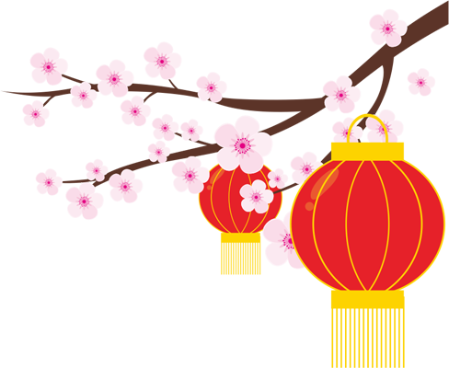
媽咪我愛你!

Mom I love you
HAPPY
MOTHER’S DAY

