化學 HOWHOW HOW玩

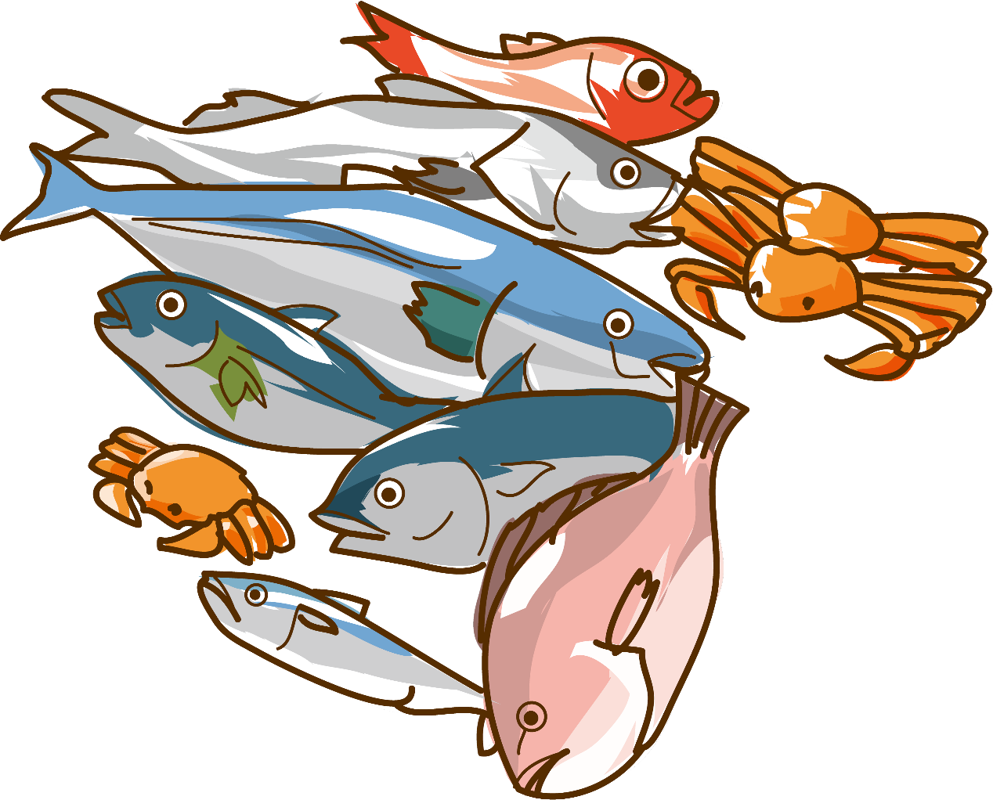

英文
http://www.kaimalo.com/img/4cec2a3dde1bad6ccd6d8dbcaa4d.html
https://www.youtube.com/watch?v=EGGdcbHgRHo
http://www.ntsec.edu.tw/UserFiles/image/Science_study_monthly/2019/58-02/index/58-02-001-%E5%9C%966.jpg
中文
https://www.lifechem.tw/periodictable.html
單個元素下載
https://www.lifechem.tw/uploads/4/0/1/0/40100751/01.jpg
(01是編號)[1-9前面要加上0]{100-118直接放}
屬性
https://www.lifechem.tw/periodictable.html
影片
https://www.bilibili.com/video/av17688317?from=search&seid=4071242211986791807
https://www.bilibili.com/video/BV1Nb411E7Np/?spm_id_from=333.788.videocard.0
https://www.youtube.com/watch?v=TuAoQZq4Gk4
https://www.techbang.com/posts/73379-following-a-150-year-periodic-table-of-elements-it-may-now-be-necessary-to-update-the-replacement
https://topic.epa.gov.tw/chemiknowledgemap/cp-224-8002-b156a-5.html

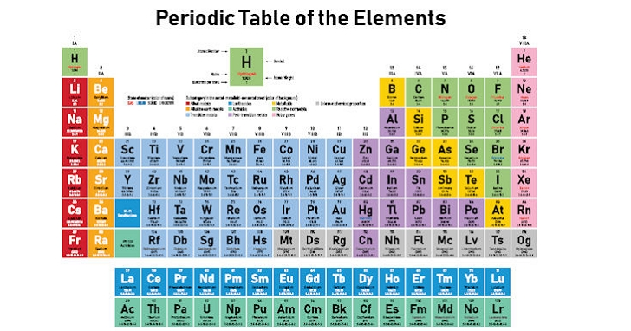
. http://mail1.ctsh.mlc.edu.tw/~ctsh_h/cthchem/psweb/newspaper/atomic_weight.html

