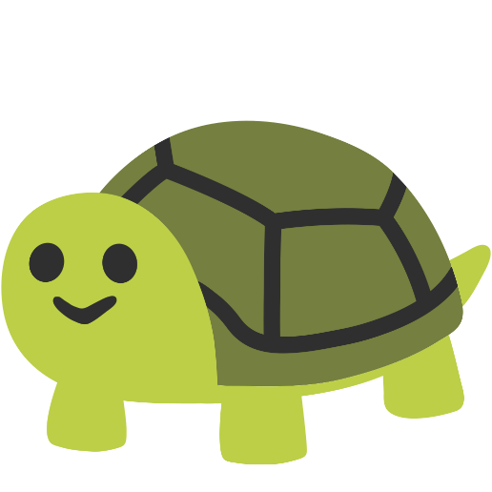
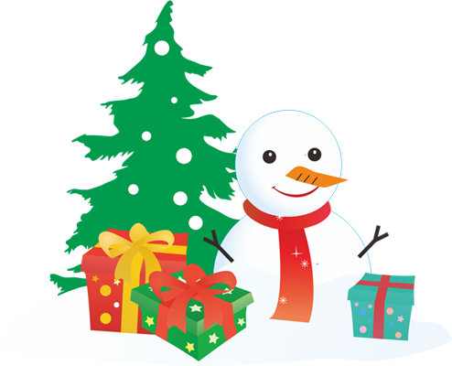
40409
This is a banana.

Only for you

只有為你
HAPPY
FATHER’S
DAY!

